Note: This document is “view only”. Please create a copy of this document and save it to your drive.

**SOP- Creating Standard Operating Procedures- Systems Vault**

**PREREQUISITES**

[Master: SOP- Standard Operating Procedures- Systems Vault](https://docs.google.com/document/u/0/d/1P8URSBV8z47y77ZGJGUbzm-qVnItlp-NJmbVZygxfIM/edit)

2. SN SOP FOLDERS

3. SN MASTER DOCS

Google Drive

[Template: SOP Template- Systems Vault](https://docs.google.com/document/d/138q0Z-ZUXtoOqlrDHJv85eI6QVAYQI8eZ2foNZXuJ_c/edit?usp=sharing)

[Master: Guidelines- Naming Conventions- Systems Vault](https://docs.google.com/document/u/0/d/1IsYwJoykfoADN6hC3jGEgms5vz92vpVEAHWlxIMMJW8/edit)

[Master: SOPs- Systems Vault](https://docs.google.com/spreadsheets/u/0/d/1z1XxJf0lB-WdKR4mwtZVZffvMCbQZgRgtZTYUzNiMCE/edit)

[SOP- Archiving Standard Operating Procedure- Systems Vault](https://docs.google.com/document/u/0/d/1xNYP7ppBBQP_joHPy0tgEkUNALOJP1HG_h-7OPqaG80/edit)

[Teamwork PM](http://www.sarahnoked.com/teamwork)

[SOP- Creating Templates & Supporting Docs- Systems Vault](https://docs.google.com/document/u/0/d/1gXt067q-3l7ZiGqmqJc83gsqWHMxls7NSSW_fODW9mQ/edit)

**PURPOSE**Standard Operating Procedures (SOPs) are the bread and butter of our business and allow us to maintain a high level of quality assurance and standardization in the way we operate. As such, SOPs are a big part of our company culture and contribute successfully to our ability to scale and operate with a virtual team. Having documented and maintained procedures and processes in place for every recurring task in the business allows us to streamline systems, be as productive as possible (i.e. no need to reinvent the wheel every time) and take holidays and leave. In short, we love SOPs!

**POLICY**

When creating SOPs ALWAYS use your @sarahnoked.com to login to Google Drive and create the SOPs. Never use a personal gmail account to create SOPs

All SOPs must follow the layout in [Template: SOP Template- Systems Vault](https://docs.google.com/document/d/138q0Z-ZUXtoOqlrDHJv85eI6QVAYQI8eZ2foNZXuJ_c/edit?usp=sharing) including font size, line spacing, headers, etc. (no exceptions!).

All SOPs must follow the naming conventions guidelines specified in [Master: Guidelines- Naming Conventions- Systems Vault](https://docs.google.com/document/u/0/d/1IsYwJoykfoADN6hC3jGEgms5vz92vpVEAHWlxIMMJW8/edit)

SOPs are put in place for ALL recurring tasks in Sarah Noked OBM and recurring tasks are linked in to recurring tasks in [Teamwork PM](https://sarahnoked.teamwork.com/) for ease of access.

All SOPs can be found in [2. SN SOP FOLDERS](https://drive.google.com/drive/folders/1Wn0vJMGyxugVe8MzBhEzayOM143-rpZp?usp=sharing). All Sarah Noked OBM Team Members have access to our SOPs folder if they have an @sarahnoked.com email address

Subfolder Definitions:

1. [OPERATIONS & SUPPORT (SOPs)- Systems Vault](https://drive.google.com/open?id=1p4iQ3rWYJMiLJd0jpxqlClq22Hx5gPC6)- All SOPs that deal supporting the SOPs- like admin and things that go into maintaining the day to day operations
2. [SALES & PRODUCTS (SOPs)- Systems Vault-](https://drive.google.com/open?id=1hCuFqV9VUB7rO-G1xfA8N5d1ruFDCAQo) All SOPs that deal with the selling, launching and creating products
3. [MARKETING (SOPs)- Systems Vault](https://drive.google.com/open?id=1vXtTM6zYbGUCsufFexhDz4xCvS-YaKQ7)- All SOPs that deal with the marketing, advertising and promotion
4. [DELIVERY (SOPs)- Systems Vault](https://drive.google.com/open?id=1Hykfo-iA0aB_8mznWPbiY_C7t127nHsz)- All SOPs that deal with the delivery of our products and services
5. [GROWTH (SOPs)- Systems Vault](https://drive.google.com/open?id=1-ueXx5cWlUUDUA_hvfLl3NJ0_8TzRvwU)- All SOPs the deal with training, onboarding and offboarding team members

In each SOP folder in Google Drive there is a subfolder that exists and uses the naming convention: TEMPLATES FOR XXX (SOPs - Internal)- Sarah Noked OBM >>> This is where any templates relating to specific SOPs are saved. To create templates, refer to this SOP: [SOP- Creating Templates & Supporting Docs- Systems Vault](https://docs.google.com/document/u/0/d/1gXt067q-3l7ZiGqmqJc83gsqWHMxls7NSSW_fODW9mQ/edit)

In each SOP folder in Google Drive there is a subfolder that exists and uses the naming convention: SUPPORTING DOCS FOR XXX (SOPs - Internal)- Sarah Noked OBM >>> This is where the and supporting docs relating to specific SOPs are saved. These are typically screencasts.

All SOPs (upon creation) must be updated to [Master: SOPs- Systems Vault](https://docs.google.com/spreadsheets/u/0/d/1z1XxJf0lB-WdKR4mwtZVZffvMCbQZgRgtZTYUzNiMCE/edit) in the appropriate section of this spreadsheet

All SOPs created must fall under a SOP MASTER FOLDER. No exceptions. Under each SOP Subfolder are multiple SOP MASTER FOLDERS that use this naming convention:.SOP MASTER FOLDER- XXX (SOPs - Internal)- Sarah Noked OBM

When referencing software and other SOPs they must be hyperlinked and if mentioning a file or SOP it must use the exact title of the file, hyperlinked to the file.

If you need to create a Master Doc refer to this SOP:

**PARTY**

All Team Members

**PROPERTY**

Online Business Manager

**PROCESS**

Part 1: Set up to Create the SOP

Part 2: Create the SOP

Part 3: Request Review

Part 4: Finalize SOP

Part 5: Archive SOP

**PROCEDURE**

**Part 1: Set up to Create the SOP**

1. Log in to Google Drive
2. Create a copy of [Template: SOP Template- Systems Vault](https://docs.google.com/document/d/138q0Z-ZUXtoOqlrDHJv85eI6QVAYQI8eZ2foNZXuJ_c/edit?usp=sharing) and move to the appropriate SOP Subfolder and then to the appropriate .SOP MASTER FOLDER within the subfolder. >>> If you are unclear where the SOP should live refer to the “Subfolder Definitions” in our “Policy” above or consult with the Online Business Manager.
3. Rename this SOP using the naming conventions [Master: Guidelines- Naming Conventions- Systems Vault](https://docs.google.com/document/u/0/d/1IsYwJoykfoADN6hC3jGEgms5vz92vpVEAHWlxIMMJW8/edit)and make sure to preface the title in the doc and the name title with (Review):

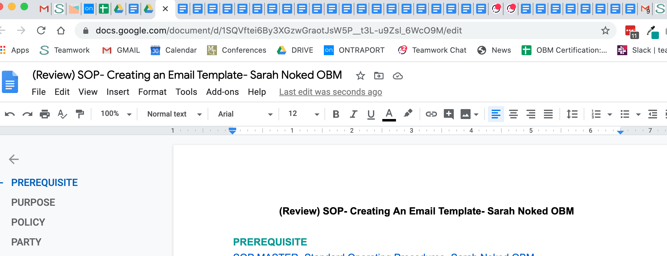

1. Make file accessible to SN Staff
   1. Navigate to File > Share and make sure that the file can be accessed by and is editable to all Sarah Noked users (team members with an @sarahnoked.com email address):

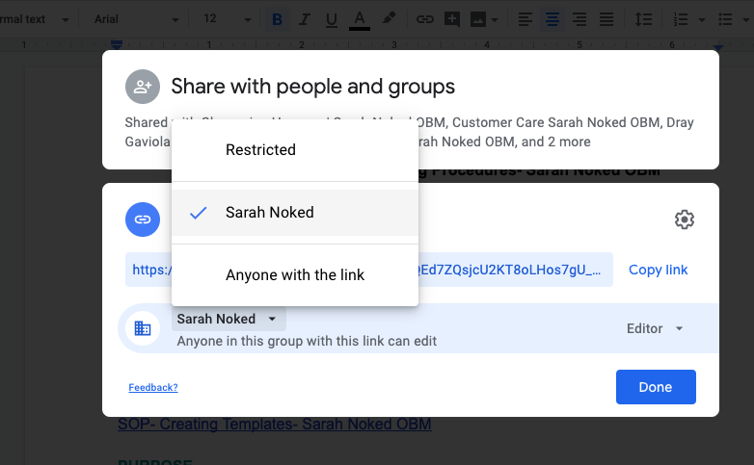

1. Update [Master: SOPs- Systems Vault](https://docs.google.com/spreadsheets/u/0/d/1z1XxJf0lB-WdKR4mwtZVZffvMCbQZgRgtZTYUzNiMCE/edit) with details
   1. Navigate to the correct section (note that SOPs are broken down by subfolders)
   2. Create a new line in the section and update details
   3. Indicate the status of the SOP as “under review”
   4. Fill out all the information listed

**Part 2: Create the SOP**

1. PREREQUISITES- Link any Prerequisites using the correct name of the linked files, etc.:
   1. Link the connected Master SOPs and SOPs, and documents using the exact names hyperlinked
   2. List and link any tools or softwares needed to perform this task, using the exact names hyperlinked. For example:
      1. [Teamwork PM](http://sarahnoked.com/teamwork)
      2. Google Drive
2. POLICIES- Link any important Policies
3. PARTY- Include Party:
   1. Party is who will be completing task on a day to day and can be a single person or group of people
4. PROPERTY- Include Property:
   1. Property is one of the OBMs on the team who is responsible for ensuring the SOPs stay updated
5. PROCESS- Outline the Process
   1. Be thoughtful about how the steps happen
   2. Streamline as much as possible
6. PROCEDURE: Outline the Procedure
   1. Add in screenshots where necessary to describe steps
   2. Add in screencasts where necessary and save the screencast to the “SUPPORTING DOCS” folder, grab the URL and link to the procedure and in the prerequisites
7. Double-Check Your Work: When you’ve finished the task, do the following to double-check everything is complete. Re-read to review for any steps missed and/or listed twice

**Part 3: Request SOP review**

1. Create a new task in the [Teamwork PM](http://sarahnoked.com/teamwork) Project “Sarah Noked Projects” in the task list “CURRENT SOP Sprint”
2. The title of the task should include the name of the SOP.

For example- REVIEW - SOP - Creating an automation for an opt-in in Ontraport - Sarah Noked OBM https://docs.google.com/document/xxx”

1. Assign the SOP to the “Property Owner” you’ve established in the SOP and notify the person responsible for reviewing via Teamwork PM. Coassign yourself on this task for followup and follow the SOP all the way through to completion.

**Part 4: Finalize SOP**

1. Update [Master: SOPs- Systems Vault](https://docs.google.com/spreadsheets/u/0/d/1z1XxJf0lB-WdKR4mwtZVZffvMCbQZgRgtZTYUzNiMCE/edit) with status “approved”
2. Remove the preface “(Review)” from the title of the Google Doc and the title listed within the Google Doc

**Part 5: Archive SOP**

1. See [SOP- Archiving Standard Operating Procedure- Systems Vault](https://docs.google.com/document/u/0/d/1xNYP7ppBBQP_joHPy0tgEkUNALOJP1HG_h-7OPqaG80/edit)

**Created by:**

**Department:** Growth

**Date:**

**Revised:**

**Revised by:**